2.88: a) 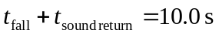
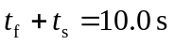 (1)

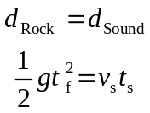
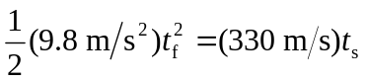 (2)

Combine (1) and (2): 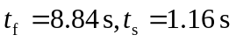
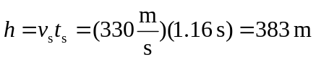
b) You would think that the rock fell for 10 s, not 8.84 s, so you would have thought it fell farther. Therefore your answer would be an overestimate of the cliff's height.

